LAB ACTIVITY (Exp-05)

1. Implement queue operations using Array.

#include <stdio.h>
#include <stdlib.h>
#define MAX 5

int queue[MAX];
int front = -1, rear = -1;

void enqueue(int x) {
if (rear == MAX - 1) {
printf("Queue Overflow\n");
return;
}
if (front == -1) front = 0;
queue[++rear] = x;
printf("%d enqueued\n", x);
}

void dequeue() {
if (front == -1 || front > rear) {
printf("Queue Underflow\n");
return;
}
printf("%d dequeued\n", queue[front++]);
}

void display() {
if (front == -1 || front > rear) {
printf("Queue is empty\n");
return;
}
printf("Queue elements: ");
for (int i = front; i <= rear; i++)
printf("%d ", queue[i]);
printf("\n");
}

int main() {
int choice, value;
while (1) {
printf("\n--- Queue using Array ---\n");
printf("1. Enqueue\n2. Dequeue\n3. Display\n4. Exit\n");
printf("Enter your choice: ");
scanf("%d", &choice);

switch (choice) {
case 1:
printf("Enter value to enqueue: ");
scanf("%d", &value);
enqueue(value);
break;
case 2:
dequeue();
break;
case 3:
display();
break;
case 4:
exit(0);
default:
printf("Invalid choice!\n");
}
}
return 0;
}

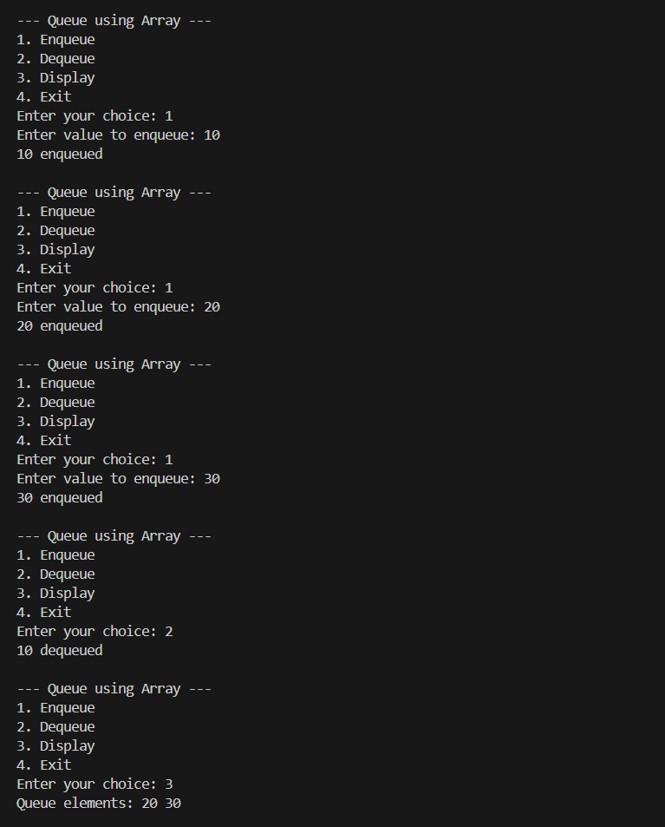

2. Implement queue operations using Linked list.

#include <stdio.h>
#include <stdlib.h>

struct Node {
int data;
struct Node* next;
};

struct Node* front = NULL;
struct Node* rear = NULL;

void enqueue(int x) {
struct Node* temp = (struct Node*)malloc(sizeof(struct Node));
temp->data = x;
temp->next = NULL;

if (rear == NULL) {
front = rear = temp;
} else {
rear->next = temp;
rear = temp;
}
printf("%d enqueued\n", x);
}

void dequeue() {
if (front == NULL) {
printf("Queue Underflow\n");
return;
}
struct Node* temp = front;
printf("%d dequeued\n", front->data);
front = front->next;
if (front == NULL) rear = NULL;
free(temp);
}

void display() {
if (front == NULL) {
printf("Queue is empty\n");
return;
}
struct Node* temp = front;
printf("Queue elements: ");
while (temp != NULL) {
printf("%d ", temp->data);
temp = temp->next;
}
printf("\n");
}

int main() {
int choice, value;
while (1) {
printf("\n--- Queue using Linked List ---\n");
printf("1. Enqueue\n2. Dequeue\n3. Display\n4. Exit\n");
printf("Enter your choice: ");
scanf("%d", &choice);

switch (choice) {
case 1:
printf("Enter value to enqueue: ");
scanf("%d", &value);
enqueue(value);
break;
case 2:
dequeue();
break;
case 3:
display();
break;
case 4:
exit(0);
default:
printf("Invalid choice!\n");
}
}
return 0;
}

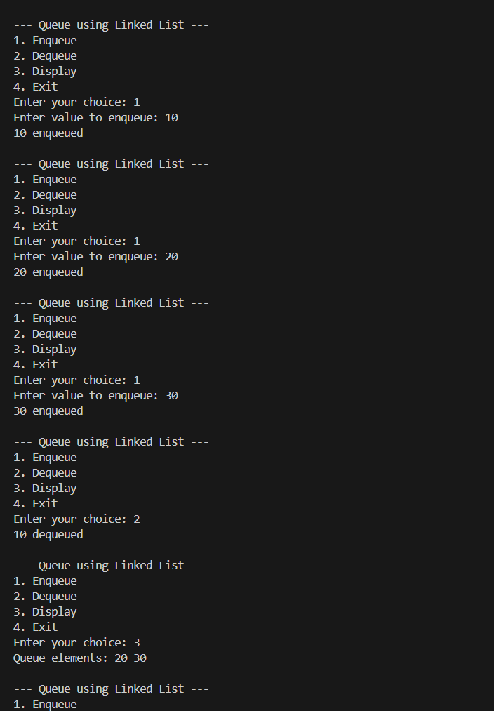

3. Implement circular queue using array and linked list
- Using Array

#include <stdio.h>
#include <stdlib.h>
#define MAX 5

int queue[MAX];
int front = -1, rear = -1;

void enqueue(int x) {
if ((rear + 1) % MAX == front) {
printf("Circular Queue Overflow\n");
return;
}
if (front == -1) {
front = rear = 0;
} else {
rear = (rear + 1) % MAX;
}
queue[rear] = x;
printf("%d enqueued\n", x);
}

void dequeue() {
if (front == -1) {
printf("Circular Queue Underflow\n");
return;
}
int x = queue[front];
if (front == rear) {
front = rear = -1;
} else {
front = (front + 1) % MAX;
}
printf("%d dequeued\n", x);
}

void display() {
if (front == -1) {
printf("Circular Queue is empty\n");
return;
}
printf("Circular Queue elements: ");
int i = front;
while (1) {
printf("%d ", queue[i]);
if (i == rear) break;
i = (i + 1) % MAX;
}
printf("\n");
}

int main() {
int choice, value;
while (1) {
printf("\n--- Circular Queue using Array ---\n");
printf("1. Enqueue\n2. Dequeue\n3. Display\n4. Exit\n");
printf("Enter your choice: ");
scanf("%d", &choice);

switch (choice) {
case 1:
printf("Enter value to enqueue: ");
scanf("%d", &value);
enqueue(value);
break;
case 2:
dequeue();
break;
case 3:
display();
break;
case 4:
exit(0);
default:
printf("Invalid choice!\n");
}
}
return 0;
}

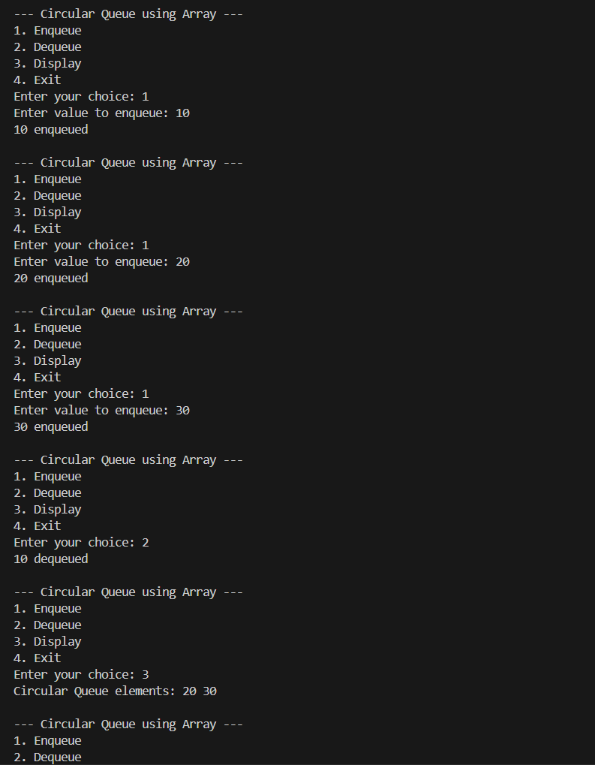

- Using Linked List
#include <stdio.h>
#include <stdlib.h>

struct Node {
int data;
struct Node* next;
};

struct Node* front = NULL;
struct Node* rear = NULL;

int size = 0;
int N = 5;

void enqueue(int x) {
if (size == N) {
printf("Circular Queue Overflow\n");
return;
}

struct Node* temp = (struct Node*)malloc(sizeof(struct Node));
temp->data = x;
temp->next = NULL;

if (front == NULL) {
front = rear = temp;
rear->next = front;
} else {
rear->next = temp;
rear = temp;
rear->next = front;
}

size = (size + 1) % (N + 1);
printf("%d enqueued\n", x);
}

void dequeue() {
if (front == NULL) {
printf("Circular Queue Underflow\n");
return;
}

int x;
if (front == rear) {
x = front->data;
free(front);
front = rear = NULL;
} else {
struct Node* temp = front;
x = temp->data;
front = front->next;
rear->next = front;
free(temp);
}

size--;
printf("%d dequeued\n", x);
}

void display() {
if (front == NULL) {
printf("Circular Queue is empty\n");
return;
}

printf("Circular Queue elements: ");
struct Node* temp = front;
do {
printf("%d ", temp->data);
temp = temp->next;
} while (temp != front);
printf("\n");
}

int main() {
int choice, value;
while (1) {
printf("\n--- Circular Queue using Linked List ---\n");
printf("1. Enqueue\n2. Dequeue\n3. Display\n4. Exit\n");
printf("Enter your choice: ");
scanf("%d", &choice);

switch (choice) {
case 1:
printf("Enter value to enqueue: ");
scanf("%d", &value);
enqueue(value);
break;
case 2:
dequeue();
break;
case 3:
display();
break;
case 4:
exit(0);
default:
printf("Invalid choice!\n");
}
}
return 0;
}

